Name: ____________________________________________________________________ Period: ______________
Wednesday, January 9th Homework: Angles
1.  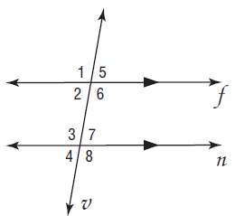 | - List two pair of supplementary angles.  - List all of the corresponding angles (4)  - List all of the alternate interior angles (2)  - List all of the alternate exterior angles (2)  - Find all missing angle lengths and write in the diagram.
2.  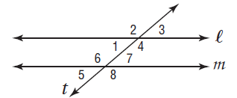  140⁰ | - List two pair of supplementary angles.  - List all of the corresponding angles (4)  - List all of the alternate interior angles (2)  - List all of the alternate exterior angles (2)  - Find all missing angle lengths and write in the diagram.

Name: ____________________________________________________________________ Period: ______________
Wednesday, January 9th Homework: Angles
1. | - List two pair of supplementary angles.  - List all of the corresponding angles (4)  - List all of the alternate interior angles (2)  - List all of the alternate exterior angles (2)  - Find all missing angle lengths and write in the diagram.
2.  140⁰ | - List two pair of supplementary angles.  - List all of the corresponding angles (4)  - List all of the alternate interior angles (2)  - List all of the alternate exterior angles (2)  - Find all missing angle lengths and write in the diagram.

3.  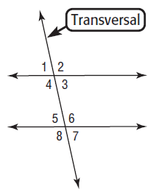 | - List two pair of supplementary angles.  - List all of the corresponding angles (4)  - List all of the alternate interior angles (2)  - List all of the alternate exterior angles (2)  - Find all missing angle lengths and write in the diagram.
4.  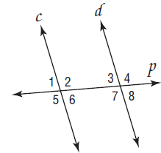  120⁰ | - List two pair of supplementary angles.  - List all of the corresponding angles (4)  - List all of the alternate interior angles (2)  - List all of the alternate exterior angles (2)  - Find all missing angle lengths and write in the diagram.

3. | - List two pair of supplementary angles.  - List all of the corresponding angles (4)  - List all of the alternate interior angles (2)  - List all of the alternate exterior angles (2)  - Find all missing angle lengths and write in the diagram.
4.  120⁰ | - List two pair of supplementary angles.  - List all of the corresponding angles (4)  - List all of the alternate interior angles (2)  - List all of the alternate exterior angles (2)  - Find all missing angle lengths and write in the diagram.

