Name: _______________________________________________________________________________ Period: ________________
Week of Tuesday, January 22nd – Thursday, January 24th Guided Notes: Data Analysis
Tuesday, January 22nd
> Do Now:
- Ms. Misconish runs 26.2 miles in 5.5 hours. What was her speed?

- Order the following numbers from least to greatest: A) 3% B) 1/3 C)30% D)√9

- If f(x) = 30-0.5x and g(x) = 2x – 15, what is the solution for x when f(x) = g(x)?

> Gallery Walk Observations:
Graph 1: | Graph 2:
Graph 3: | Graph 4:
Graph 5: | Graph 6:
> Interpreting Graphs Vocabulary:
- Interpret: ____________________________________________________________________________________________________.
- Increase: _____________________________________________________________________________________________________.
- Decrease: ____________________________________________________________________________________________________.
- Constant: _____________________________________________________________________________________________________.

Increasing Graphs Decreasing Graph Constant Graph

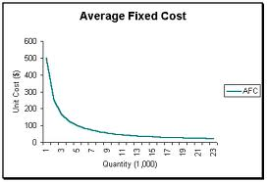
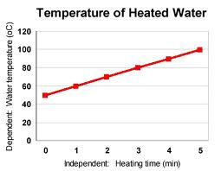

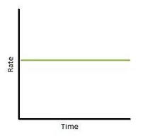

> Interpreting Graph Practice:
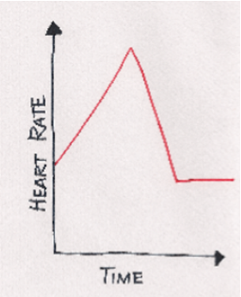  - Based on the graph, which statement best describes the change in Jenny’s heart rate?  - Jenny’s heart rate increased, then decreased, and then stayed constant.  - Jenny’s heart rate increased, then stayed constant, and then decreased.  - Jenny’s heart rate decreased, then increased, and then stayed constant.  - Jenny’s heart rate decreased, then stayed constant, and then increased. | 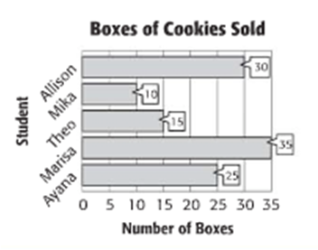  - Based on the graph, which statement best describes the amount of cookies sold?  - Allison sold 15 more boxes than Ayana.  - Allison sold 3 times more cookies than Mika.  - Marisa sold the least amount of cookies.  - Ayana sold the most cookies.
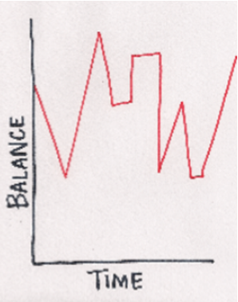  - Based on the graph, which statement about the bank account balance is true?  - The balance was highest near the beginning of the period.  - The balance was lowest in the middle of this time period.  - The balance was constant throughout this time period.  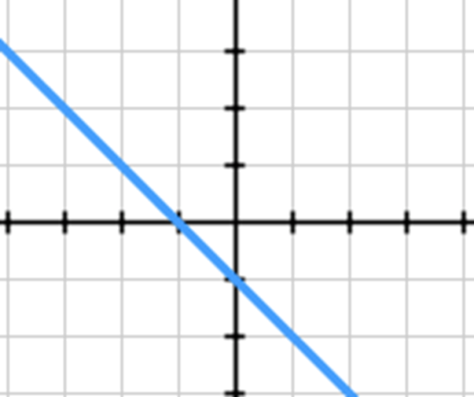  - The balance increased steadily over this time period. | 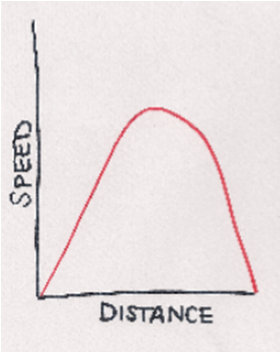  - Based on the graph, which statement about the speed is true?  - The speed increased and then increased.  - The speed increased and then remained constant.  - The speed increased and then decreased.  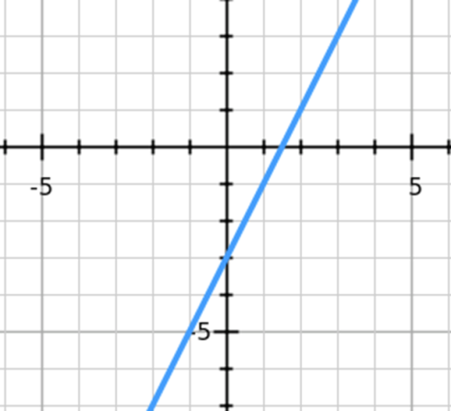  - The speed decreased and then remained constant
Wednesday, January 23rd
> Do Now:
Write an equation for the 1. 2.
following graphs in slope intercept form.

> What Type of Correlation?
1. 2. 3. 4. 5.
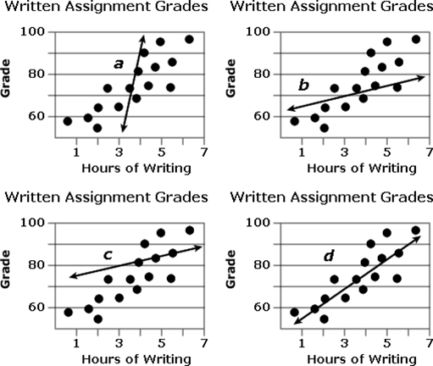
> Scatter Plots:
- A scatterplot can be used _______________________________________________
________________________________________________________________________.
- A best fit line makes this possible.
- Best fit line/ Line of best fit: _____________________________________________
____________________________________________________________________________
_________________________________________________________________________.

> Making Predictions:
Example 1: Based on the info in the graph, what is a logical prediction about the number of gallons of water consumed in week 8 of a drought?  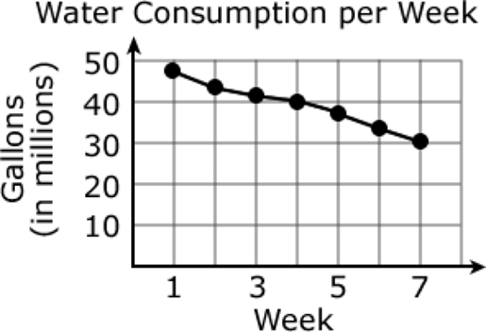  - About 10 gallons of water will be consumed.  - About 13 gallons of water will be consumed.  - About 22 gallons of water will be consumed.  - About 28 gallons of water will be consumed. | Example 2: Based on the information in the graph, what is a logical prediction for the population in New York City in 2001?  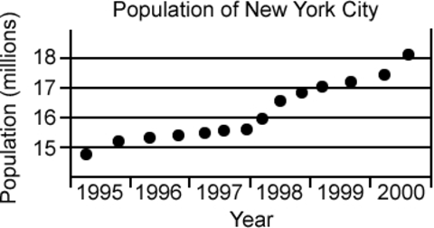  - The population of New York City will be around 18 million people.  - The population of New York City will be around 20 million people.  - The population of New York City will be around 25 million people.  - The population of New York City will be around 29 million people.
Example 3: Based on the information in the graph, what is a logical prediction for movie sales during the week of 7/16?  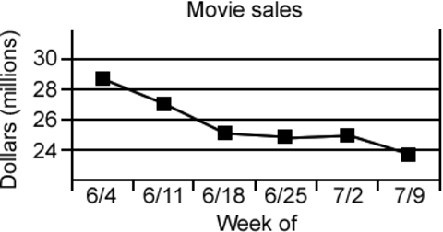  - Movie sales will be around 24 million dollars.  - Movie sales will be around 20 million dollars.  - Movie sales will be around 16 million dollars. | Example 4: What is a logical prediction about  the temperature inside of the oven at 11 minutes?  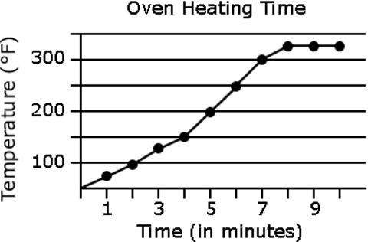  - The temperature inside the oven will be 300° F.  - The temperature inside the oven will be 325° F.  - The temperature inside the oven will be 375° F.  - The temperature inside the oven will be 425° F.
Example 5: What happens to a person's running speed as they get older?  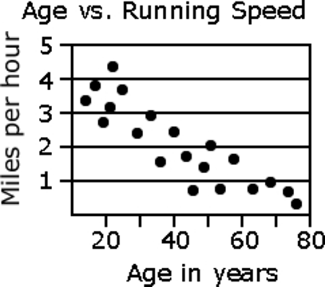  - It increases.  - It decreases.  - It stays the same.  - It increases, then decreases. | Example 6: The scatter plot shows the arm span of 8th grade students according to their height. If a student in this class is 62 inches tall, what is their approximate arm span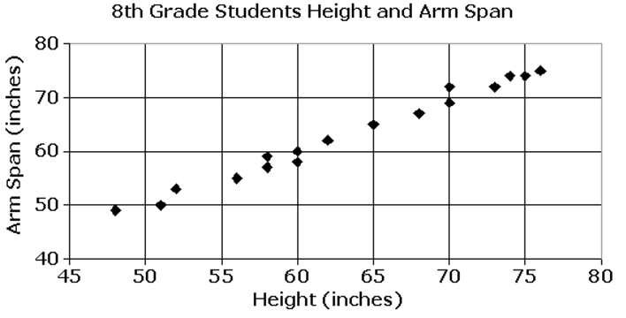  - 52 in.  - 55 in.  - 62 in.  - 72 in.
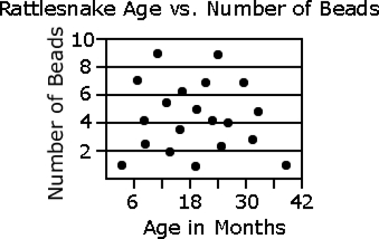
Example 7: Which statement is true?
- As a rattlesnake gets older, it grows more beads.
- As a rattlesnake gets older, it grows fewer beads.
- A 18-month-old rattlesnake has more beads than a 6-month-old
rattlesnake.
- There is no relationship between the rattlesnake's age and the number
of beads it has.

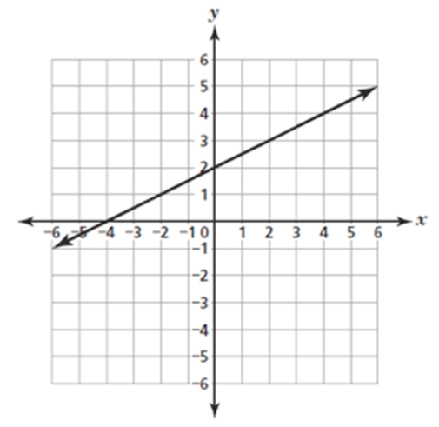
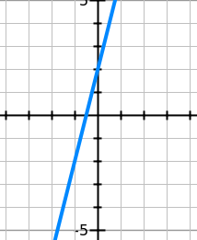
Thursday, January 24th
>Do Now:
- Write an equation for the following 1. 2.
graphs in slope intercept form.

> Best Fit Lines:
- Sometimes, you will have to determine the equation of the best fit line.
- In order to do this, we will simply use the y-intercept and slope (which we already know how to do! ) and check the line.
- How to determine the equation of a best fit line:
  - Determine if the line has __________________________________________________________
  - Determine the ______________________________________
  - Determine the ______________________________________
  - ________________________________________ with the best fit line.
** Eliminate any answer choices (if possible) at each step!
Example 1: Which of the following equations best fits the scatter plot?  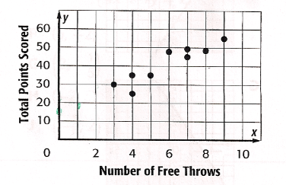  - y = 5x + 15  - y = 40  - y = 5x + 55  - y = 3x + 10 | Example 2: Which of the following equations represents a line of best fit for this scatterplot?  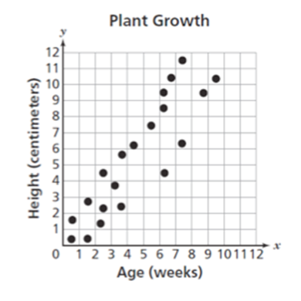  - y = 5/7x  - y = 5/6x  - y = 6/5x  - y = 9/5x
Example 3: Which equation best fits the scatterplot?  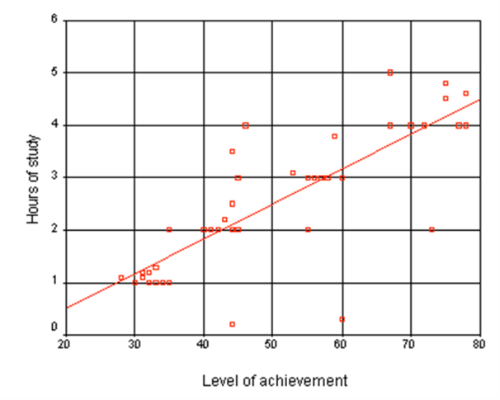  - y = 2x + 0.5  - y = 1/3x + 0.5  - y = ½x + 0.5  - y = ½x | Example 4: Which equation best fits the scatterplot?  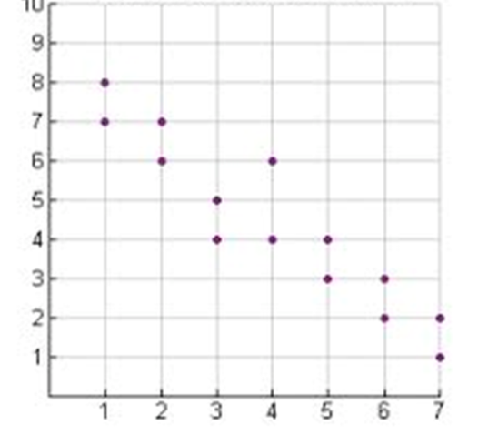  - y = x + 8  - y = x – 8  - y = -x + 8  - y = -x – 8
Example 5: Write an equation for scatter plot below.  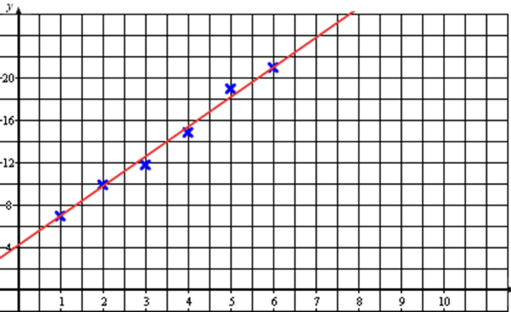 | Example 6: Write an equation for scatter plot below.  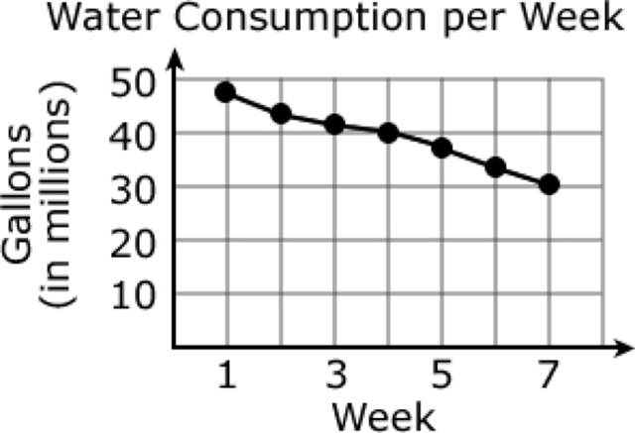
Example 7: Write an equation for scatter plot below.  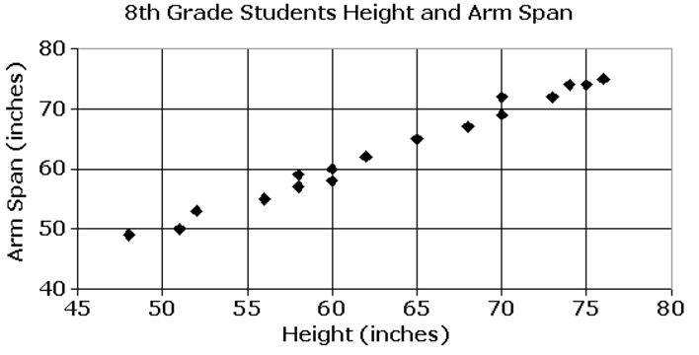 | Example 8: Write an equation for scatter plot below.  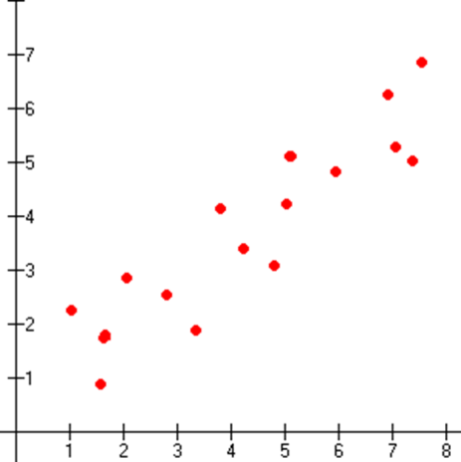
Example 9: Write an equation for scatter plot below.  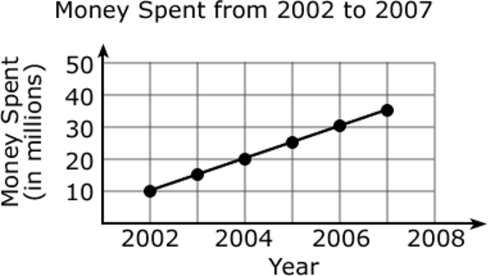 | Example 10: Write an equation for scatter plot below.  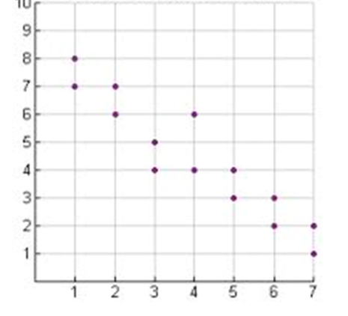
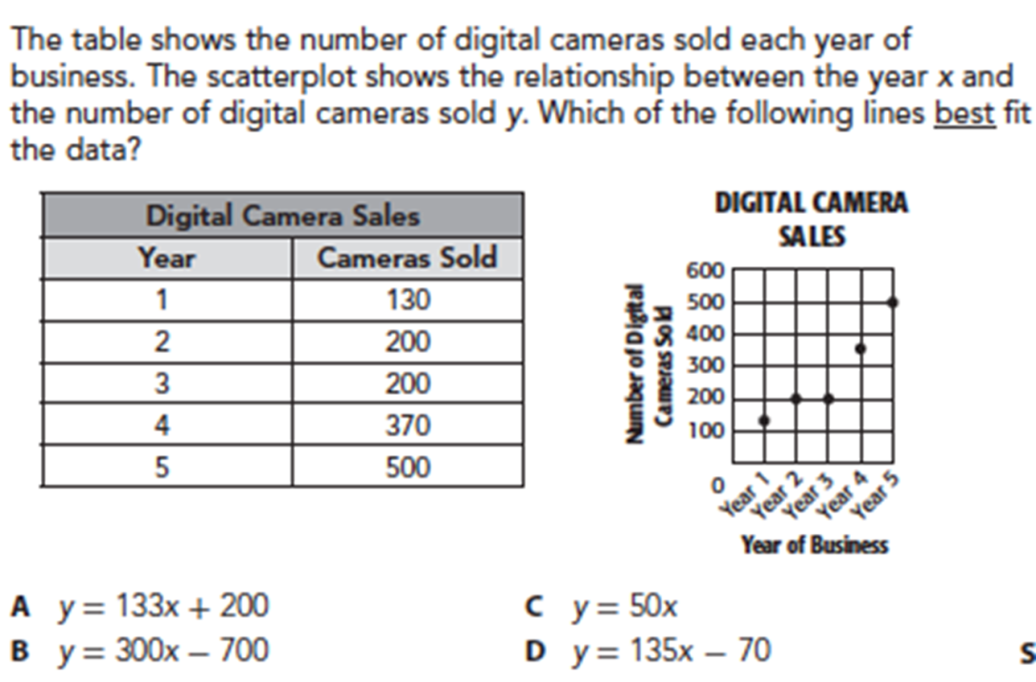
Example 11:

