Name: ______________________________________________________________________ Period: __________________
Week of Monday, January 7-Wednesday, January 9th Guided Notes: Angles
Monday, January 7th
> Do Now
- Write the equation for the Pythagorean theorem and identify each variable in the equation.
- Write an expression of how you would find the length ofleg n? – DO NOT SOLVE!
11
n
5
- Write a triplet of numbers that represent the lengths of a right triangle and satisfy the Pythagorean theorem.

> Angles
- Every triangle and geometric shape we encounter is made of angles. As long as we know the measurement of one angle, we can find the measurement of many other angles.

> Angles Vocabulary
- Angle: _______________________________________________________________________________________________________________________
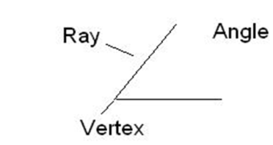
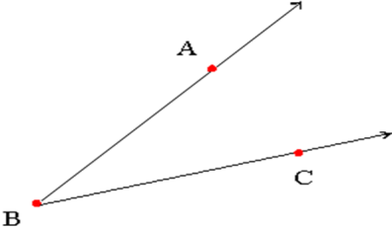
- There are 3 ways to name an angle:
- Angle ABC or ABC
- Angle CBA or CBA
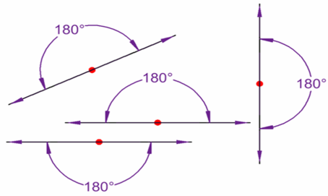
- Angle B or B

- Straight Angle: _____________________________________________________________________
- Looks like a straight line

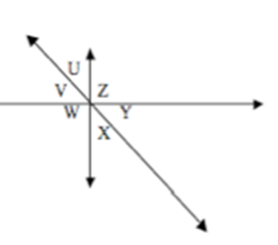
- Complementary Angles: _______________________________________________________________________________________
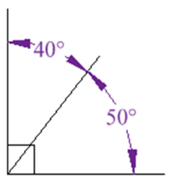
- Look for a ________________________ to help identify.
- Angle U & Angle V are complementary.
- Angle Y & Angle X are complementary.

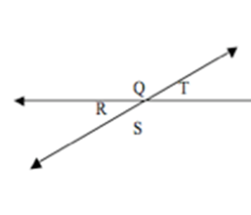
- Supplementary Angles: ______________________________________________________________________________________
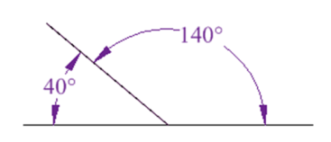
- Look for a straight angle to help identify.
- Angles Q & T are supplementary.
- Angles R & S are supplementary.

> Examples: Identify as complementary, supplementary, or neither.
1.  120⁰ 60⁰ | 2.  30⁰ 60⁰
3.  75⁰ 75⁰ | 4.  25⁰  65⁰
5.  40⁰ 60⁰ | 6.  90⁰ 50⁰
7. - Measure of angle 1: 110°  - Measure of angle 2: 70° | 8. - Measure of angle 1: 22°  - Measure of angle 2: 68°

- Transversal:_____________________________________________________________________________________________________
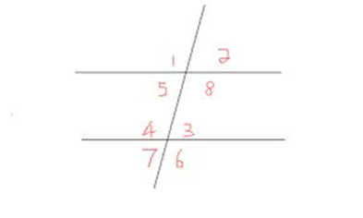
  - Diagram: line intersecting L & M
- Parallel Lines:__________________________________________________________________________________
  - Diagram: L & M
L
- Congruent (≅): _______________________________________________
M
- Vertical Angles: ______________________________________________________________________
__________________________________________________________________________________________
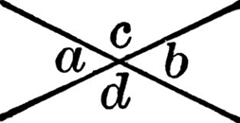
  - These angles are _____________________________________________________________________
  - Diagram: Angles 1 & 8, Angles 4 & 6
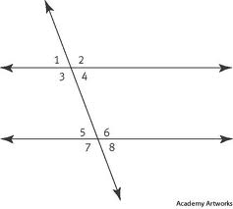
  - A & B are vertical, C & D are vertical.

- Interior Angles:___________________________________________________________________________________
  - These are _______________________________________________
  - Angles 3, 4, 5, & 6
- Exterior Angles:____________________________________________________________________________________
  - These are ___________________________________
  - Angles 1, 2, 7, 8
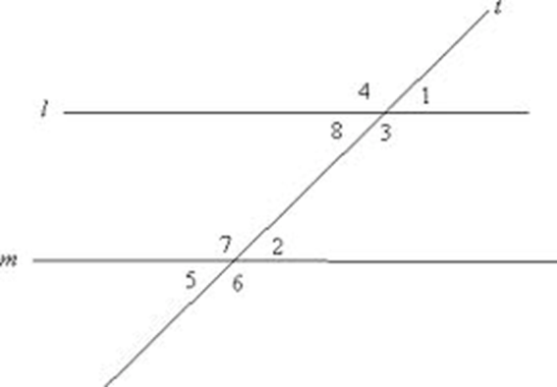
>Examples:
9. Identify the angles that are vertical. 10. Identify the interior angles.

11. Identify the exterior angles.
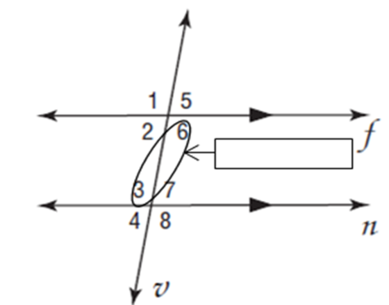
- Alternate Interior Angles:___________________________________________________________________
__________________________________________________________________________________________________
  - These are __________________________
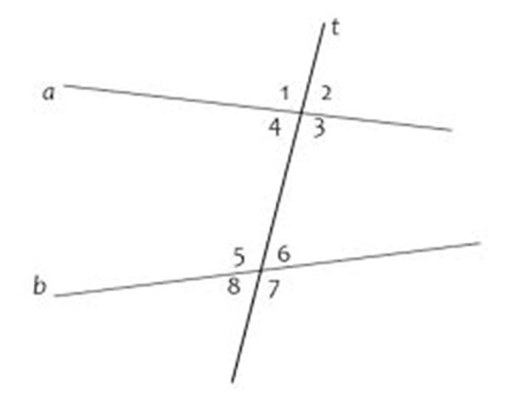
  - 6 & 3 are alt. int., 2 & 7 are alt. int.

> Example:
12. Identify the sets of alternate interior angles.
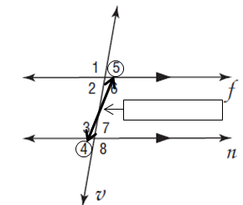
- Alternate Exterior Angles:_______________________________________________________________
___________________________________________________________________________________________________
  - These angles are ___________________________
  - 4 & 5 are alt. ext.
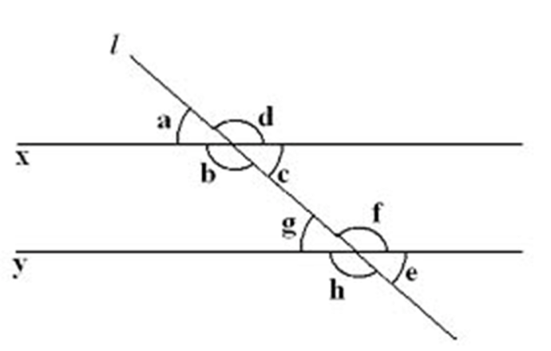
  - 1 & 8 are alt. ext.

> Example:
13. Identify the sets of alternate exterior angles:

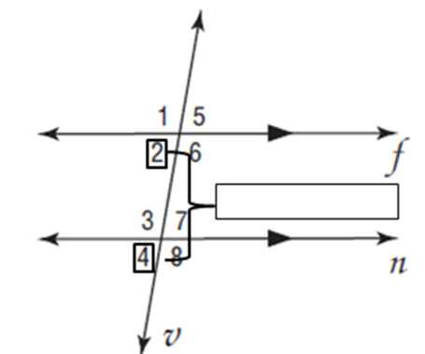

- Corresponding Angles: ___________________________________________________________________
________________________________________________________________________________________________
  - Both are on the ___________________________________________________________
  - These are ___________________________________
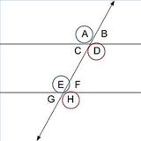
  - 2 & 4 are corresponding
  - 1 & 3 are corresponding

> Example:
14. Identify the sets of corresponding angles:

Tuesday, January 8th
1. Clear off your desk and prepare for your vocabulary quiz.

> Finding the Missing Measure of an Angle
- Now that we understand the definitions and have seen what the definitions mean on a diagram, we are going to apply them to determine the missing measures of angles.

Angle Measurement | Reason
Given: 105° | Given.
∠2 =
∠3 =
∠4 =
∠5 =
∠6 =
∠7 =
∠8 =
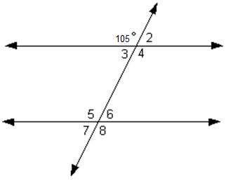
> Example 1:

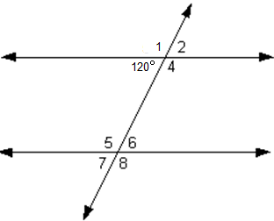

Angle Measurement | Reason
Given: 120° | Given.
∠1 =
∠2 =
∠4 =
∠5 =
∠6 =
∠7 =
∠8 =
> Example 2:

Wednesday, January 9th
> Do Now:
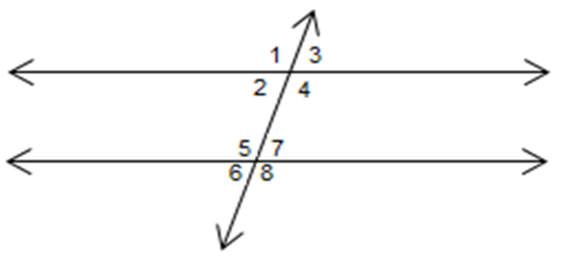
- Name a pair of alternate interior angles.

- Name a pair of alternate exterior angles.
97⁰

- Name a pair of vertical angles.

- Determine the measurement of Angle 4.

