Name: ____________________________________________________________________ Period: ___________________
Monday December 3-Thursday December 6 Guided Notes: Slope Intercept Form & Linear Equations
Monday, December 3rd
> Do Now:
- Write the slope-intercept form equation.

- Identify all the variables in the slope-intercept form equation.

- Identify the slope and y-intercept of the equation: 3x = 12y - 21

> Converting From Standard Form to Slope Intercept Form
- As a reminder, you can not identify the slope or the y-intercept of a an equation without it being in slope-intercept form.
- When converting an equation from standard form to slope-intercept form, follow these steps:
- ______________________________________________________________________________________________________________________
- Identify what _____________________________________________________ to make the equation look like y = mx + b.
- Move terms to the correct side by ____________________________________________________________________________________
- ________________________ if there is a coefficient, other than 1, _________________________________________________________
- ____________________________________________ all terms.

Example Problems: (Convert the equation and ID the slope and y-int)
1. 10x = -2y + 14 | 2. -6y + 24 = -30x
3. 2 = 5x – 6y | 4. 9x = -18 + 27y
5. -77x = 11y – 22 | 6. -95y = -190 – 95x
7. 8x = 64 – 72y | 8. -1 = 10x – 4y
9. -3x = -10 + 7y | 10. -2x = -1 – 8y
11. 5y = -10 + 15x | 12. 7x = -28y + 9
13. -10 = 50y + 25 | 14. -9y = -36 + 45x
Tuesday, December 4th
> Do Now:
- Identify the slope and y-intercept: 4x = -12 + 8y

- Identify the slope and y-intercept: 12x = 24y - 48

Example Problems: (Convert the equation and ID the slope and y-int)
1. -10 = 20x + 5y | 2. -21 = 7x -14y
3. 9y = 36 – 18x | 4. -15x = 30y - 10
5. 2x -4y = 8 | 6. 3y = 12 – 6x
7. 8x = -16y + 32 | 8. 20x = 40y - 20
9. 6x + 3y = -24 | 10. 8x = 2y + 32
11. -15x – 30 = 5y | 12. 28 – 14y = 7x
13. -6x + 12 = 3y | 14. 16 = 32x – 8y
15. 4x = 12y + 16 | 16. 30 = -60x + 15y
17. 12y = -24 + 6y | 18. -15x = 30 - 3y
19. 22x = 88 – 11y | 20. -75 = 25x + 5y
Wednesday, December 5th
> Do Now:
- Identify the slope and y-intercept -12 = 24x + 48y

- What is the slope of a line that passes through (-10, 5) & (20 – 15)?

> Identifying Coordinates and Values
- On the Tcap, they will ask for the ordered pair of the y-intercept.
- The y-intercpet is always on the y-axis so the __________________________________________________________________________
____________________________________________________________ and the y coordinate is wherever the graph crosses the y-axis. i.e. (0, y-int).
- The ordered pair for the y-intercept to the right is:

- Furthermore, the TCAP will have you identify x values on the graph.
- To find the y values, look at the x-value identified __________________________________________
______________________________________________________________________________________________
- Or, you can _____________________________________________________________________________________
- Example: If x = 2, what is the value of y?

Examples:
1. Write the ordered pair for the y-intercept.  When x = -4, what is y?  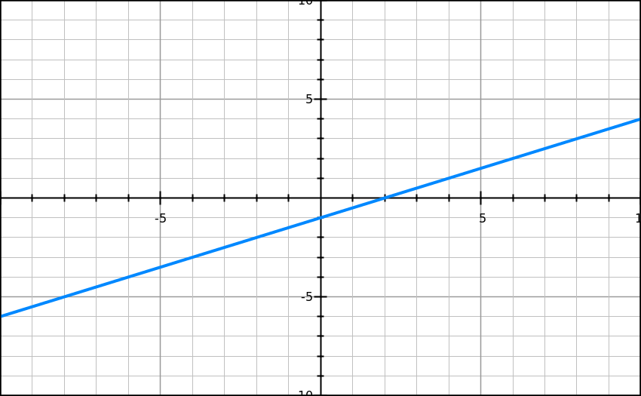 | 2. Write the ordered pair for the y-intercept.  When x = 1, what is y?  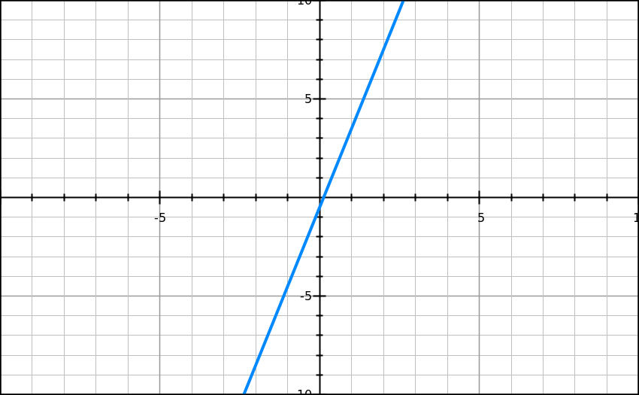
3. Write the ordered pair for the y-intercept.  When x = -4, what is y?  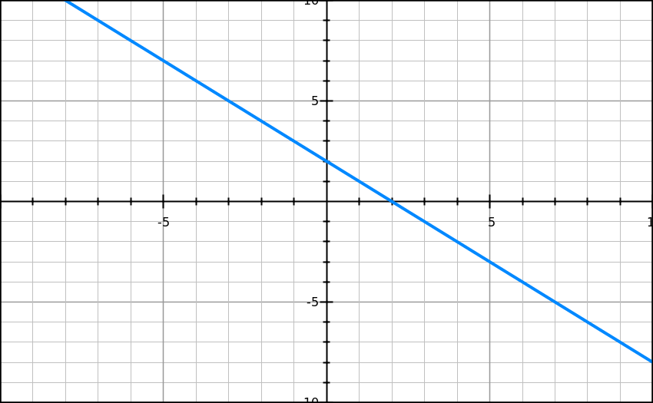 | 4. Write the ordered pair for the y-intercept. When x = 1, what is y?  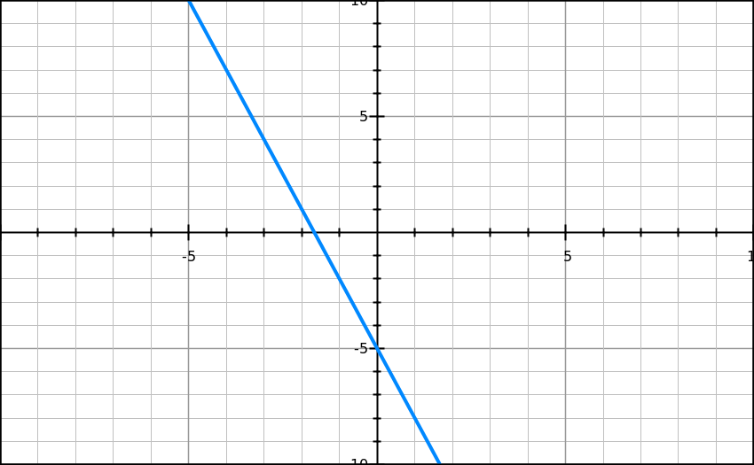
5. Write the ordered pair for the y-intercept. When x = 4, what is y?  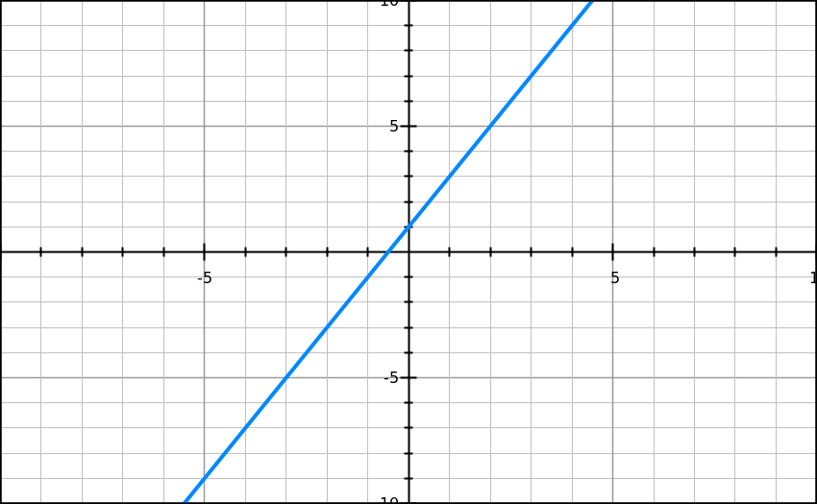 | 6. Write the ordered pair for the y-intercept. When x = -3, what is y?
7. Write the ordered pair for the y-intercept. When x = 2, what is y? | 8. Write the ordered pair for the y-intercept. When x = 2, what is y?
9. Write the ordered pair for the y-intercept. When x = 2, what is y? | 10. Write the ordered pair for the y-intercept. When x = ½, what is y?
11. Write the ordered pair for the y-intercept. When x = -3, what is y? | 12. Write the ordered pair for the y-intercept. When x = 2, what is y?
Thursday, December 5th
> Do Now:
- Identify the slope and y-intercept. 5x = 10y – 50

- Write the coordinate for the y-intercept.
- When x = 1.5, what is y?

Functions: Linear or Nonlinear
- Function: _____________________________________________________________________
- Functions can be 2 different types:
  - _____________________________________________
  - _______________________________________________

- Linear Function: A function that _______________________________________________________________________ when graphed.
  - ID’d by the following formula: y = mx + b
    - _______________________________________________________________________________________________
    - Ex: y = 2x - 7
- Nonlinear Function: A function that __________________________________________________________________ when graphed.
  - ID’d by any equation where ________________________________________________________________________
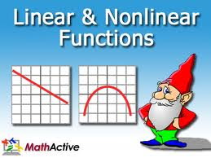
    - Ex: y = 2x² + 4

>Functions: Linear v. Nonlinear
Linear Function (y = 2x – 7) Nonlinear Function (y = 2x² – 7)

Example Problems:
1. Is this linear or nonlinear? How do you know? | 2. Is this linear or nonlinear? How do you know?

3. Is this linear or nonlinear? How do you know? | 4. Is this linear or nonlinear? How do you know?  Y³=5x
5. Is this linear or nonlinear? How do you know?  y = x³ + 2 | 6. Is this linear or nonlinear? How do you know?  y = -x – 7
7. Is this linear or nonlinear? How do you know?  y = 1/2x² – 8 | 8. Correctly pair the equation with the graph.  a) y = 1/4x – 10 b) y = 2x² + 2
9. Correctly pair the equation with the graph.  a) y = 1/2x – 3 b) y = -1/2x² – 3 | 10. Agree or Disagree with the following statement.  A linear function can be identified by an equation  (y = mx + b) where x has an exponent of 2 or greater.
11. Agree or Disagree with the following statement.

A nonlinear function looks like a line when graphed.

