Week of Tuesday November 13th - Thursday, November 15th Guided Notes: Functions & Slope
> Do Now:
- Identify the x and y coordinates for the ordered pair: (-5, 7)
- Where is the x-axis – horizontal or vertical?
- Where is the y-axis – horizontal or vertical?
- Write anything you know about slope.

>Functions
- Function: A relationship between an _____________________________________________________________________________.
  - Most functions correspond to a ___________________________________________
  - Each time you ______________________________________________________________________________.
- Linear Function: A function that is a ____________________________________________________________________________.
  - When you think of functions as a machine, there is always something you put in to get your product.
  - Think of what you put in as the INPUT. ___________________________________________________________.
  - Think of what you get out of the machine as the OUTPUT. __________________________________________
____________________________________________________________.
- The definition of a function states that each x value has exactly 1 y value.
- _____________________________________________________________________________________________________._________________________
> Example Problems: Function or Not?
X Value Y Value  -2 -4  -1 -2  0 0  1 2  2 4  1) | X Value Y Value  Brandon Blue  Josh Green  Dasha Blue  Khylee Purple  Darius Green  2)
3)  X Value Y Value  1 -7  2 -3  3 5  4 7  5 -3 | 4)  X Value Y Value  -10 10  -2 2  -1 1  10 10  2 2
X Value Y Value  0 5  1 5  2 5  3 5  0 5  5) | X Value Y Value  -3 3  -3 5  -2 2  -2 -2  -1 5  6)
X Value Y Value  -2 1  -3 1  -1 6  4 5  -3 1  7) | X Value Y Value  -2 3  -2 4  -1 5  0 6  1 7  8)
9) Does the following represent a function?  { (-9,8), (10,12), (9, 7), (8,7), (-5,3), (4, 3) } | 10) Does the following represent a function?  { (5,7), (6,7), (8, 7), (9,7), (10,7), (11, 7) }
11) Does the following represent a function?  { (-3,4), (-4,5), (-4, 4), (-5, 5), (-6,7), (-7, 7) } | 12) Does the following represent a function?  { (2,5), (3,6), (4, 3), (5, 5), (6,7), (7, 7) }
13) Does the following represent a function?  { (8,7), (9,6), (4, 3), (2, 5), (10,7), (-7, 7) } | 14) Does the following represent a function?  { (3,7), (7,6), (2, 3), (1, 5), (10,7), (-7, 7) }
15) Does the following represent a function?  { (5,7), (7,6), (12, 3), (26, 8), (8,26), (-7, 12) } | 16) What coordinate could be added to the group to make it a function?  { (-5,3), (6, 7), (10, 12), (8, 2) }  - (-3, 7)  - (6, 4)  - (-5, 7)  - (6, 8)
17) What coordinate could be added to the group to make it a function?  { (8,12), (-6, 15), (6, 15,), (6, 42) }  - (8, 12)  - (-6, 7)  - (6, 4)  - (6, 8) | 18) What coordinate could be added to the group to make it a function?  { (9,13), (4, 1), (2, 6), (8, 2) }  - (8, 12)  - ( 7, 5)  - (2, 1)  - (8, 8)
19) What coordinate could be added to the group to make it a function?  { (7, 10), (-4, 5), (8, 6), (14, 3) }  - (8, 12)  - ( 7, 5)  - (2, 1)  - (8, 8) | 20) What coordinate could be added to the group to make it a function?  { (14, 6), (3, 8), (2, 9), (11, 5) }  - (6, 8)  - ( 3, 5)  - (2, 1)  - (14, 8)
>Functions: The Vertical Line Test
- We said a function can only have 1 y value for each x value, therefore, if we look at a graph and more than one y value corresponds to an x value, the graph is not a function.
- The vertical line test states: if you draw a vertical line (up and down) through the graph and it
__________________________________________________________________.
>Vertical Line Test Examples: Are the graphs functions? Yes or No.
21)  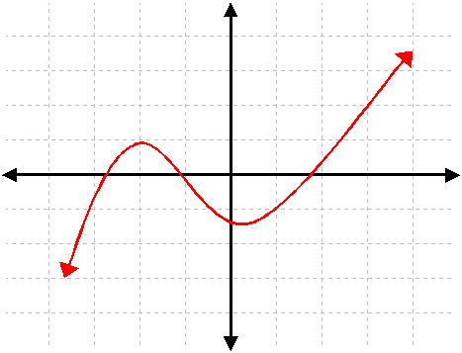 | 22)  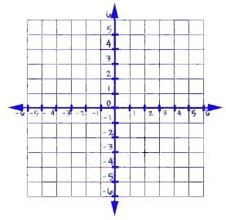
23)  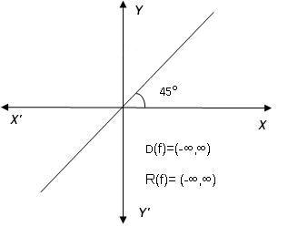 | 24)  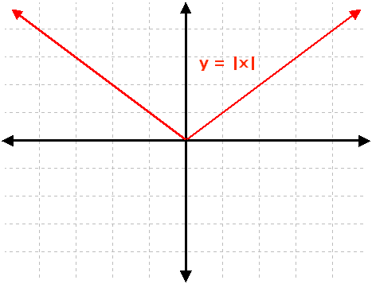
25) | 26)
Wednesday, November 14th
X | Y
-2 | -4
0 | 0
2 | 4
4 | 8
> Do Now:
- Is the table to the right a function?
- Write a definition of a function.
- Is the graph to the right a function?

- Create a set of coordinates that represent a function.
>Slope
- Slope: A number that shows how much the____________________________________________
  - Often referred to as _______________________________________
- Slope (m) is determined by calculating the change in (Δ) two y values divided by the change in (Δ) two x values.
y₂ – y₁ = Δy = rise
x₂ – x₁ Δx run
Examples:
1) What is the slope of a line that passes through (2, -5) and (6, -2)?
*Remember*: slope is the Δy divided by the Δx.
- y₂ – y₁ = (-2 - ⁻5) = 3 = 0.75
x₂ – x₁ (6 – 2) 4
- It doesn’t matter if you do y₂ – y₁ or y₁ – y_{2,} just as long as you use the same order of x coordinates.
- Look at this to understand:
- y₁ – y₂ = (-5 - ⁻2) = -3 = 0.75
x₁ – x₂ (2 – 6) -4

x | y
-1 | 1
0 | 3
1 | 5
2) The table shows the coordinates of three points contained in the graph of a line.
What is the slope of the line?

3) What is the slope of the line that passes through the points (6, 13) and (10, 21)?

4) What is the slope of the line that passes through (-4, 2) and (6, -4)?

5) What is the slope of a line that passes through (-4, 2) and (0, 0)?

6) What is the slope of a line that passes through (7, 5) and (1, 3)?

x | y
-6 | -4
0 | -2
6 | 0
7) The table shows the coordinates of three points contained in the graph of a line.
What is the slope of the line?

x | y
7 | 8
10 | 9
13 | 15
8) The table shows the coordinates of three points contained in the graph of a line.
What is the slope of the line?

x | y
5 | -4
9 | 7
14 | -12
9) The table shows the coordinates of three points contained in the graph of a line.
What is the slope of the line?

10) What is the slope of the line that passes through the points (8, 15) and (8, 19)?

x | y
7 | 10
2 | 9
1 | 6
11) The table shows the coordinates of three points contained in the graph of a line.
What is the slope of the line?
12) What is the slope of the line that passes through the points (10, 6) and (7, 4)?

Thursday, November 15th
x | y
12 | 7
14 | 5
15 | -3
> Do Now:
- What is the slope of a line that passes through the points (3,12), and (10, 2)?
- What is the slope of the line with the points given in the table to the right?

>Determining Slope From A Graph:
- In order to determine the slope of a graph, you must determine what the rise is and put it over whatever the run is.
- Pick 2 points on the graph.
  - Pick points where the line is on the ____________________________________________
- Determine the rise by going up on the graph until you reach the level of your next point.
  - ___________________________________________________________, or your rise.
- Determine the run by going left or right on the graph until you reach the next point.
  - ___________________________________________________________, or your run.
- Put your rise over your run and that is your slope.
>Examples:
1) Determine the slope of the line graphed below. | 2) Determine the slope of the line graphed below.
3) Determine the slope of the line graphed below. | 4) Determine the slope of the line graphed below.
5) Determine the slope of the line graphed below. | 6) Determine the slope of the line graphed below.  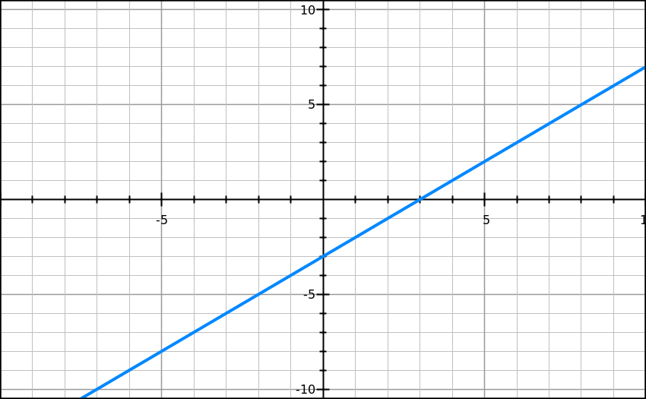
7) Determine the slope of the line graphed below.  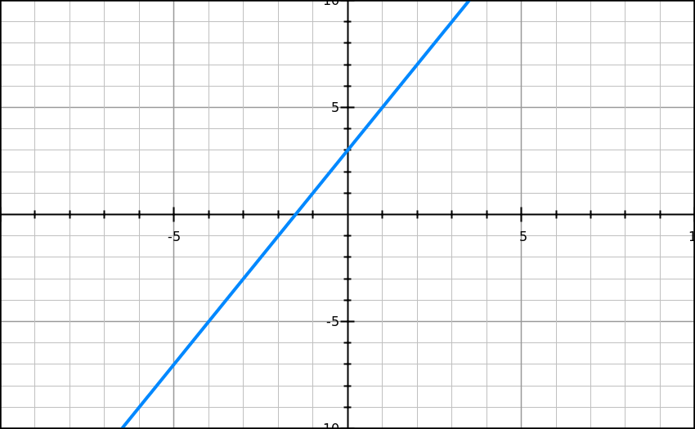 | 8) Determine the slope of the line graphed below.  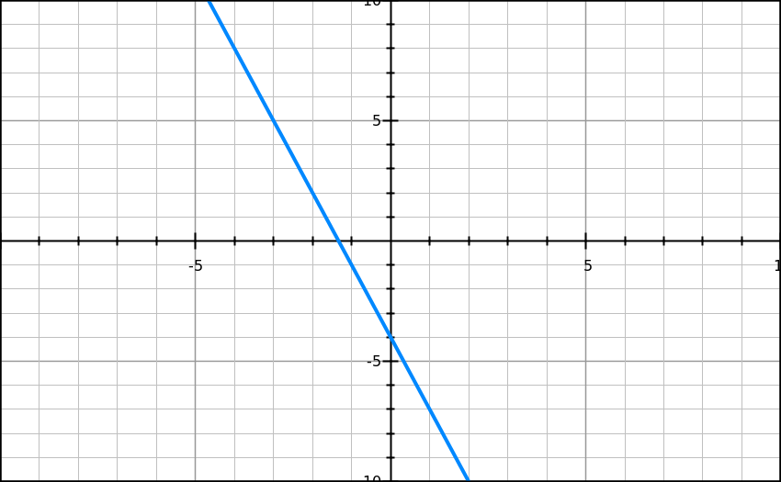
9) Determine the slope of the line graphed below.  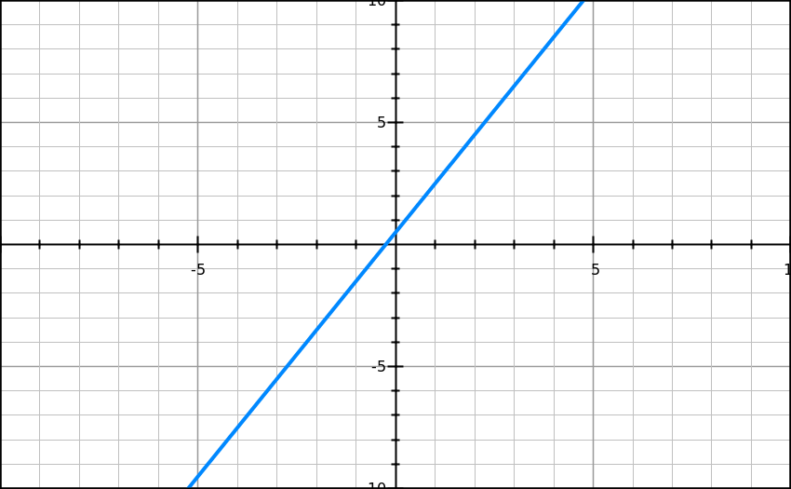 | 10) Determine the slope of the line graphed below.  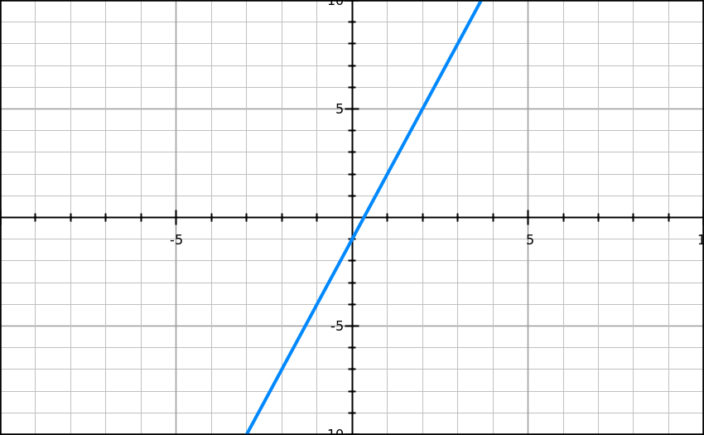
11) Determine the slope of the line graphed below.  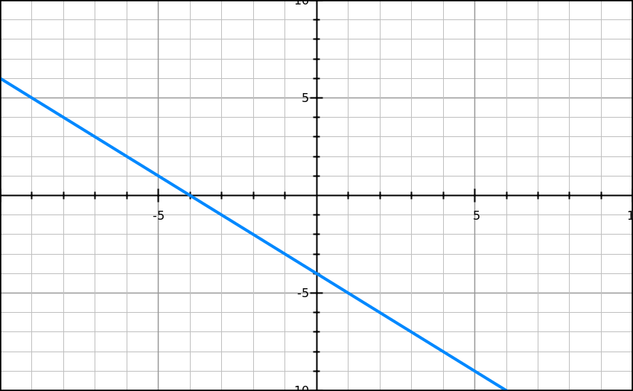 | 12) Determine the slope of the line graphed below.  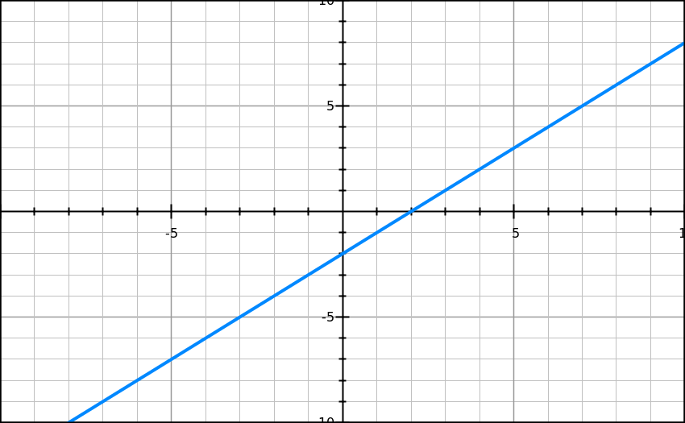
13) Determine the slope of the line graphed below.  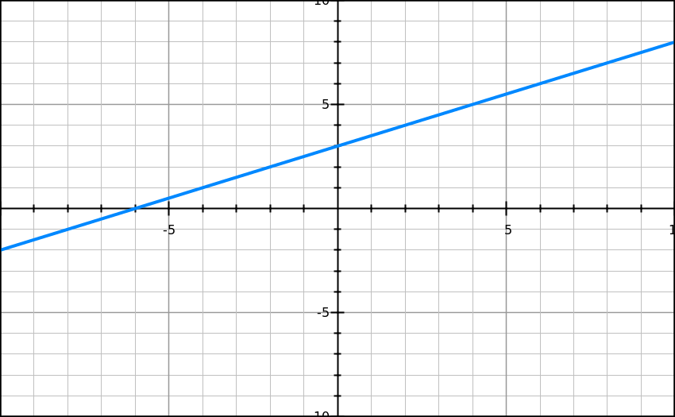 | 14) Determine the slope of the line graphed below.  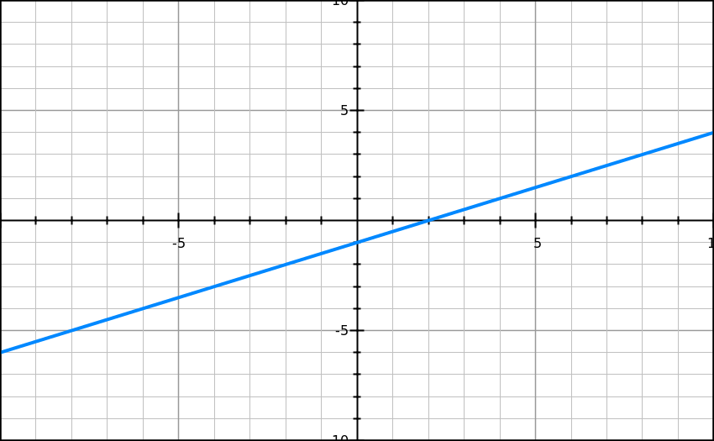
15) Determine the slope of the line graphed below.  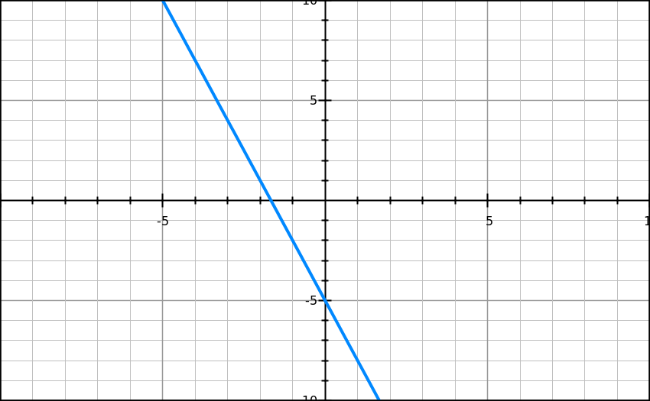 | 16) What is the slope of a line that passes through (-10, 5), (20, 10)?
17) What is the slope of the line given the table?
X | y
5 | 12
7 | 15
9 | 20

