Name: ________________________________________________________________________________________________ Period: ______________
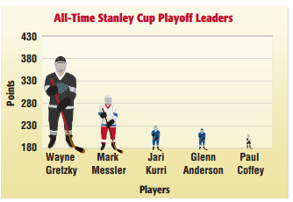
Misleading Data Homework
HOCKEY: The graph shows the all-time Stanley Cup playoff leaders.
- According to the size of the hockey players, how many times more points does Mark Messier appear to have than Jari Kurri? Explain.
- Do you think this graph is representative of the players’ number of points?

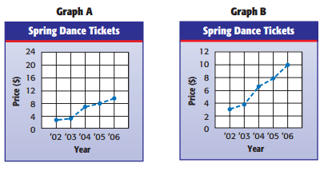
SCHOOL DANCES: The graphs show how the price of spring dance tickets increased.
- Do the graphs show the same data? If so, explain how they differ.

- Which graph makes it appear that the prices increased more rapidly?
- Which graph might student council use to show that while ticket prices have risen, the increase is not significant?

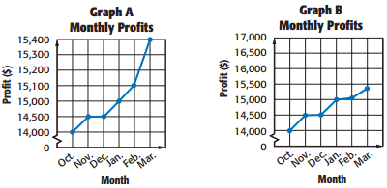
BUSINESS: The line graphs show monthly profits of a company from October to March.
- Which graph suggests that the business is extremely profitable? Is this a valid conclusion? Explain.
FITNESS: The president of a large company mailed a survey to 500 of his employees in order to determine if they use the fitness room at work. The results are shown in the graph.
- Identify any sampling errors and explain why the sample and display might be biased.

MOVIES: The manager of a movie theater asked 100 of his customers why they like to do on a Saturday night. The results are shown in the graph.
- Identify any sampling errors and explain why the sample and the display might be biased.

MARKETING: Refer to the table that gives the height of roller coasters at an amusement park. The park boasts that the average height of their roller coasters is 170 feet.
- Explain how this is misleading.

FOOD: A restaurants claims is average menu price is $3.50.
- Use the table to explain how this is misleading.

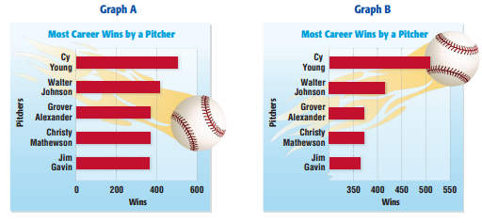

BASEBALL: Refer to the graphs below.
- Which graphs suggest that Cy Young had three times as many wins as Jim Gavin? Is this a valid conclusion? Explain.

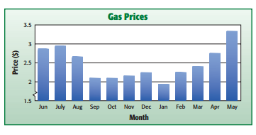
GAS: The bar graph shows monthly gas prices for 2006 – 2007.
- Why is the graph misleading?

PHONES: The manager of a telephone company mailed a survey to 400 households asking each household how they prefer to pay their monthly bill. The results are shown in the graph at the right.
- Identify any sampling errors and explain why the sample and the display might be biased.

- The bar graph shows the average number of hours each week that a group of students attend an extracurricular activity after school. Which statement best tells why the graph may be misleading if you want to use the graph to compare the number of hours the students attend an extracurricular activity.
  - The vertical scale should show days instead of hours.
  - The graph does not show which activity each person attended.
  - The intervals on the vertical scale are inconsistent.
  - The graph’s title is misleading.
- A department store mailed 100 surveys to teenagers about their preferred style of jeans. The graph shows the results. Which of the following is true concerning the sample and the display?
  - Both the display and the sample are unbiased.
  - The display is biased because the sample is biased, voluntary response sample.
  - The display is biased because the sample is biased, convenience sample.
  - The sample is biased but the display is unbiased.

