Week of Monday, August 27- Thursday, August 30: Guided Notes
Topic: Ordering numbers in different forms, and placing them on a number line
Monday, August 27th
> Place Value System
The value of a number is dependent on its ___________________________________________________________________________________.
The place value system is identified below with the following number:
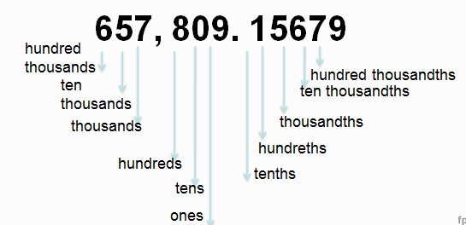
> Ordering Numbers
To order numbers in different forms, just like last week, it will be easier if they are all ____________________________________________.

- Example 1: Convert the numbers into decimal form and then order from least to greatest.
- -1 ½ = ______________, order #: ____________
- √13 = ______________, order #: ____________
- √$\frac{49}{9}$ = ______________, order #: ____________
- - $\frac{5}{8}$ = ______________, order #: ____________
- 2 ¼ = ______________, order #: ____________
- 2.37 = ______________, order #: ____________
- 1 + √9 = ______________, order #: ____________
- - 3/5 = ______________, order #: ____________
- 2 $\frac{7}{20}$ = ______________, order #: ____________
- - ¾ = ______________, order #: ____________

- Example 2: Order these numbers from least to greatest with your partner.

-30%, 2.7, √6, 25%, - 3¼

- Example 3: Order the following numbers from greatest to least with your partner.

47%, -5.3, ⅞, -42%

- Example 4: Which lists the numbers from least to greatest?

  - -3 9/10, -3.8, 2 ¼, 2.3
  - -3.8, -3 9/10, 2 ¼, 2.3
  - 2 ¼, 2.3, -3.8, -3 9/10
  - -3 9/10, -3.8, 2.3, 2 ¼

- Example 5: Which lists the numbers from greatest to least?

- 95%, 17/20, -1, -90%
- -1, 95%, -90%, 17/20
- 17/20, 95%, -90%, -1
- 95%, 17/20, -90%, -1

- Example 6: Which sentence is true?
  - -79% > -0.8
  - √35> 6
  - $4\frac{2}{3}$ = 425%
  - 62% < 0.6

- Example 7: Which lists the numbers from greatest to least?

- -6⅛, -6.05, -6.1, -6
- -6, -6.1, -6.05, -6⅛
- -6.1, -6⅛, -6.05, -6
- -6, -6.05, -6.1, -6⅛

Tuesday, August 28th

> Do Now: Answer the following SILENTLY & INDEPENDENTLY:
- Which lists the numbers in order from greatest to least?
  - √45, 4.5, 0.42, 4/7
  - 4.5, √45, 4/7, 0.42
  - 0.42, 4.5, √45, 4/7
  - √45, 4.5, 4/7, 0.42

- Which sentence is true?
  - 3.8 > 15
  - 6.5 > √44
  - √55 < 7.2
  - √84 > 9.1

> Number Lines
- Now that we know how to order our numbers, we will be placing them on a number line.
- Before we do that, we must make sure our numbers are ordered from _______________________.
- A number line is a line in which __________________________________________________
__________________________________________.
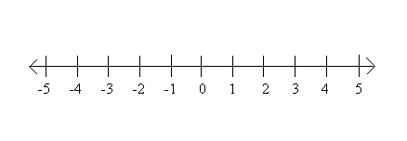

- Example 1: Draw a number line in the box given below. Take numbers from example 1 from yesterday and place them on the line. a-d we will do. e-g do with a partner. h-j do on your own!
  - Numbers from yesterday:
  - -1 ½ = ______________, order #: ____________
  - √13 = ______________, order #: ____________
  - √$\frac{49}{9}$ = ______________, order #: ____________
  - - $\frac{5}{8}$ = ______________, order #: ____________
  - 2 ¼ = ______________, order #: ____________
  - 2.37 = ______________, order #: ____________
  - 1 + √9 = ______________, order #: ____________
  - - 3/5 = ______________, order #: ____________
  - 2 $\frac{7}{20}$ = ______________, order #: ____________
  - - ¾ = ______________, order #: ____________

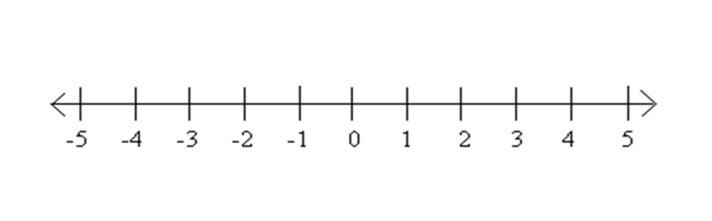
- Example 2: Put the numbers in decimal form, then order them, and finally put them on a number line.
- √4 = _________
- ½ = _________
- ¾ = _________
- -1.75 = _________
- -1 = _________
- -1.25 = _________
- 1 + √4 = _________

- Example 3: Put the numbers in decimal form, then order them, and finally put them on a number line.
- -35% = _________
- -⅓ = _________
- -½ = _________
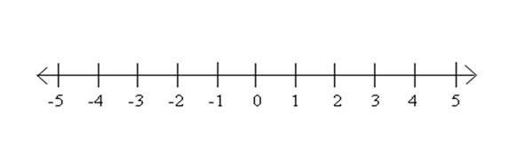
- √4 = _________
- 1 $\frac{2}{3}$ = _________
- 116% = _________
- 167% = _________

- Example 4: Which point represents √8 on the number line?

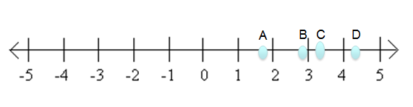
- Example 5: Which letter is located at -3?
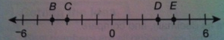

- Example 6: Which point represents the √81?
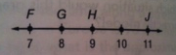
Wednesday, August 29th
> Do Now: Please respond to the following SILENTLY & INDEPENDENTLY.
- Which point on the number line best represents -2$\frac{2}{3}$?
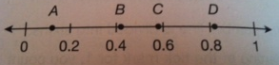

- Which point on the number line best represents 42%?

