Name: _________________________________________________________________ Period: ___________________
Homework: Converting Equations from Standard Form into Slope-Intercept Form
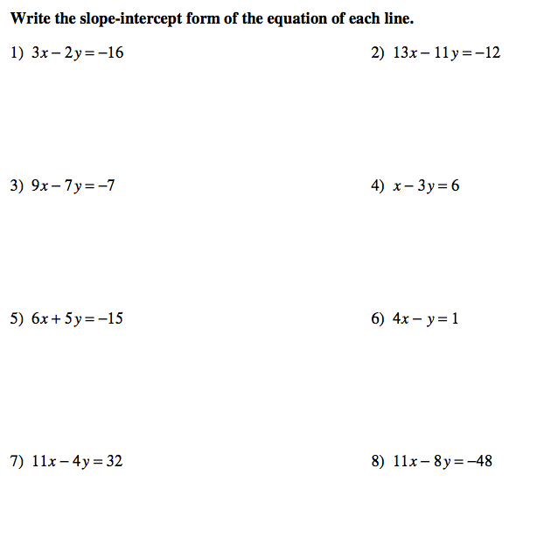
Name: _________________________________________________________________ Period: ___________________
Homework: Converting Equations from Standard Form into Slope-Intercept Form

